**Module 3**

**Auto-Scaling**

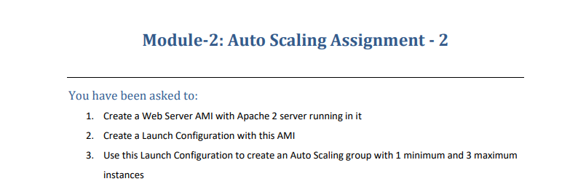

1. Create an Instance with the below userdata script.

#!/bin/bash

yum update -y

yum install -y httpd

systemctl start httpd

systemctl enable httpd

echo "<h1>Hello World from $(hostname -f)</h1>" > /var/www/html/index.html

The above Userdata Script installs httpd and enables the service.

1. Once Instance Launches, connect to the Public IP and Check if httpd is installed.

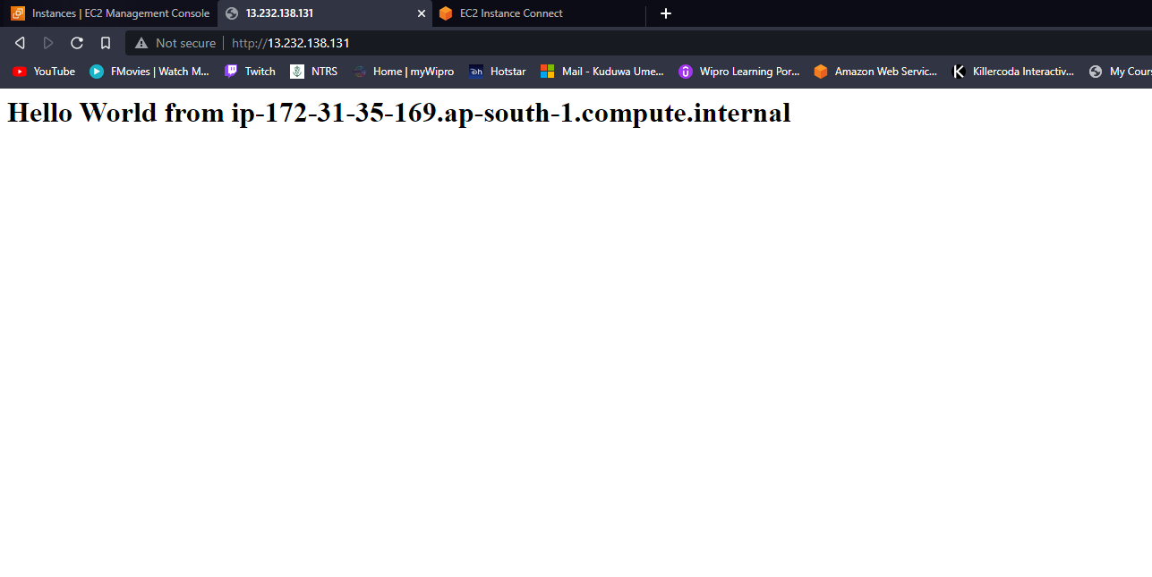

1. After launching the Instance, Create an AMI from that Instance.

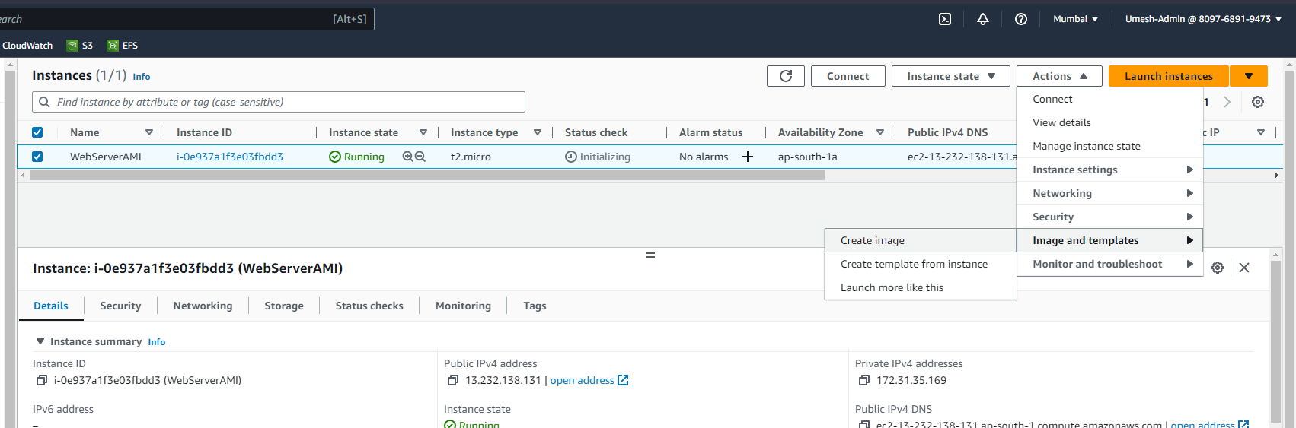

1. Check in the AMI Tab if the AMI is Created. Once the Status is Available, proceed with Auto Scaling > Launch Configuration Tab.

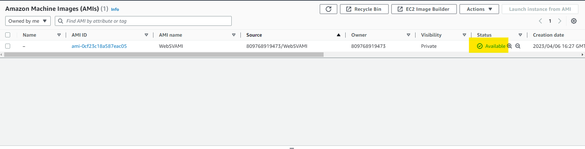

1. Fill in all the necessary Info
   1. AMI : Select the one which we created in Step 3.
   2. Instance Type : t2.micro (Free Tier)
   3. Security Group : Keep it Default SG.
   4. Key Pair : Choose the Key Pair as per your choice.

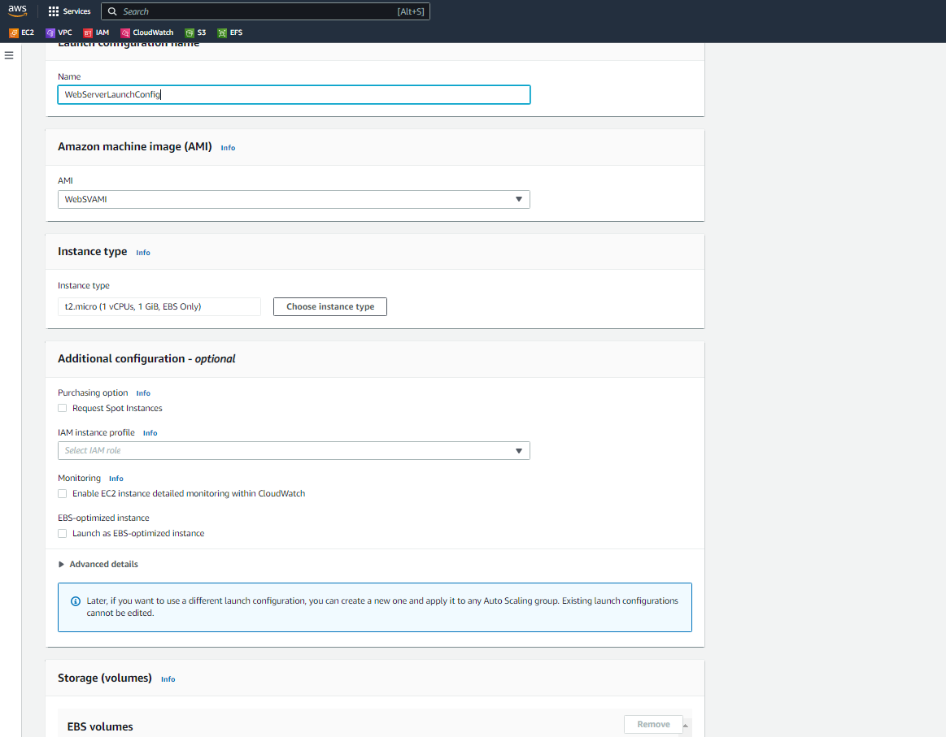

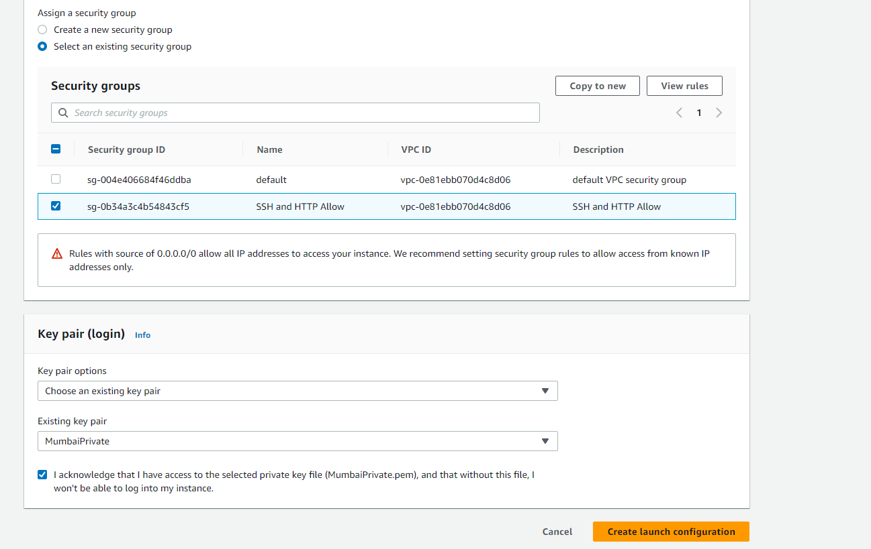

1. After creating the Launch Configuration, create an Auto Scaling Group. (Min : 1, Max : 3)

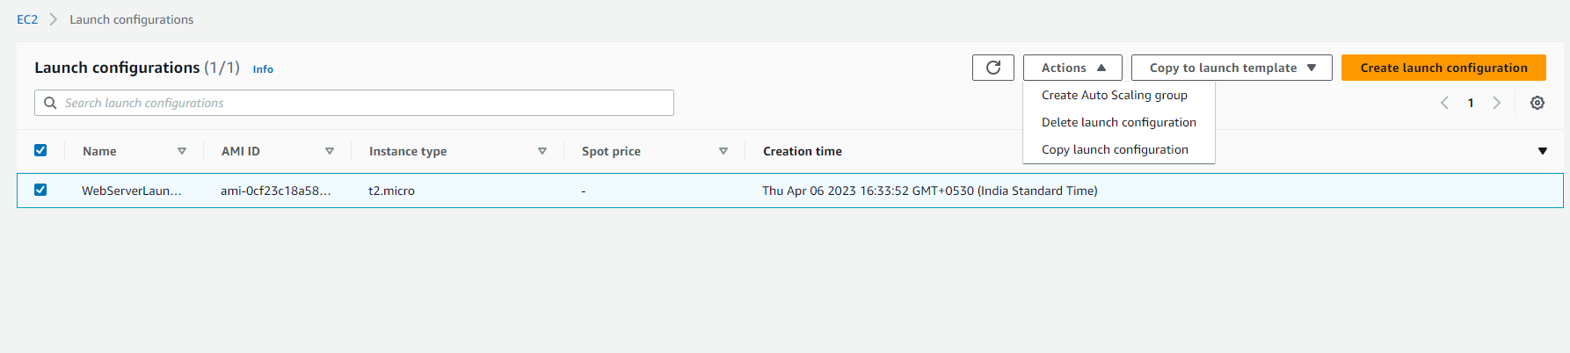

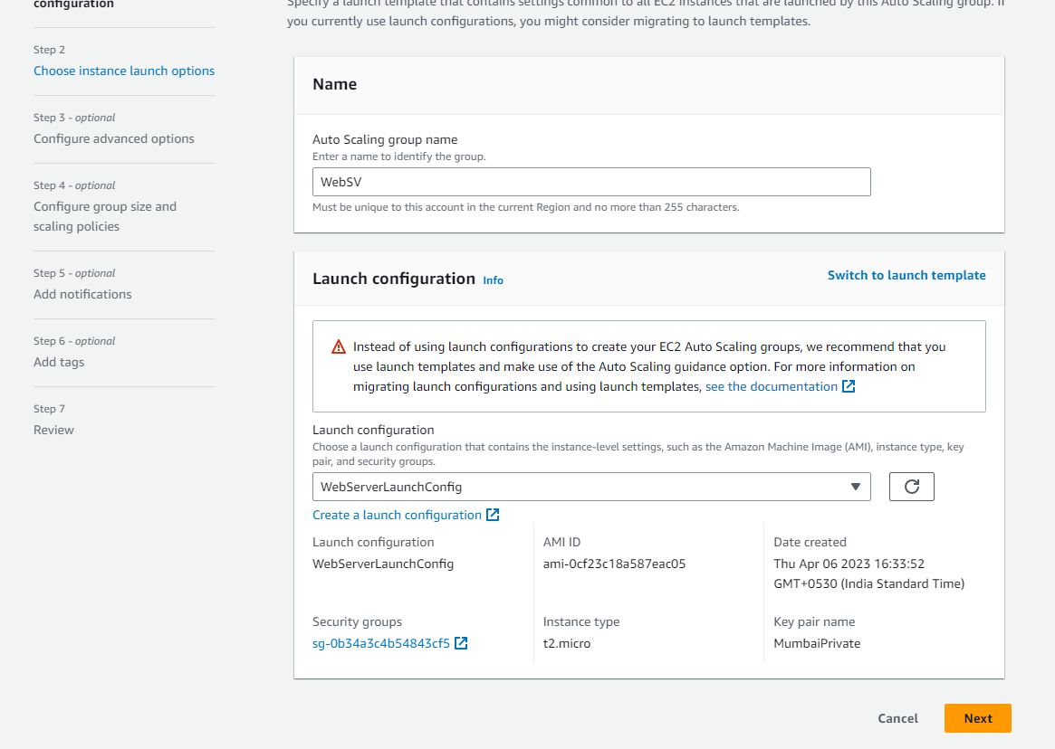

1. Review all the details and Create Auto Scaling Group.
2. Since I had put the Desired Capacity as 2, 2 new instances have been launched.

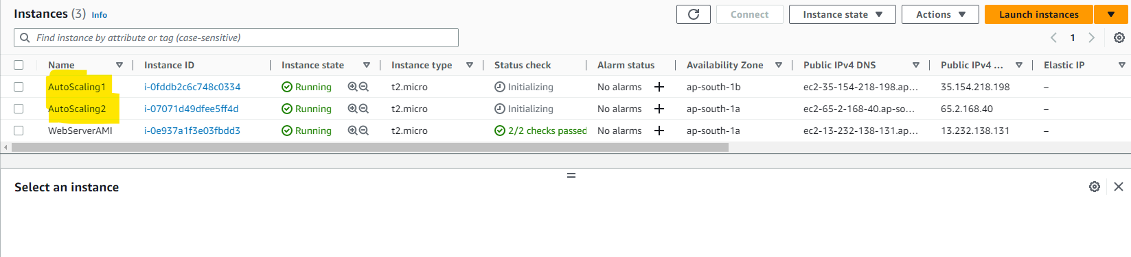

1. The 2 Instances have been configured httpd from the AMI.

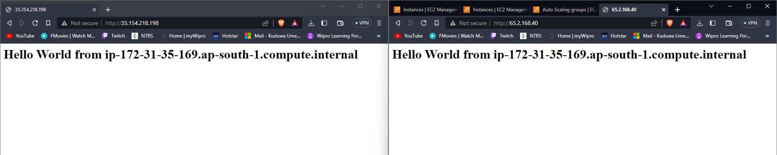

1. Terminated 1 Instance to Check If Auto Scaling is working.

